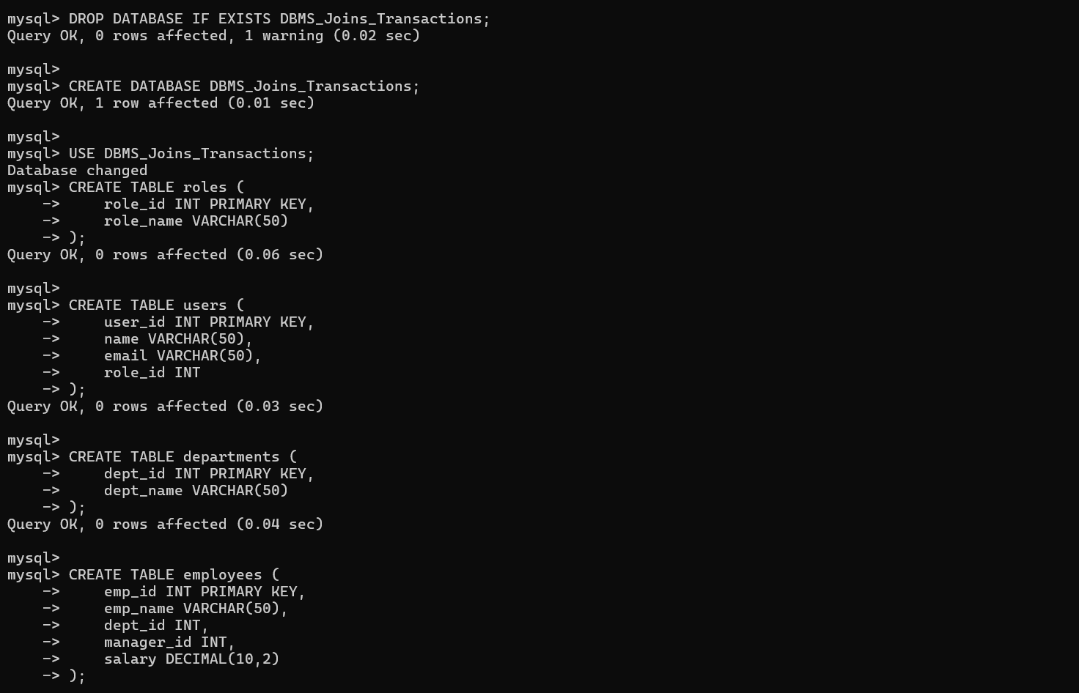
Screenshot 1: Creation of `DBMS_Transactions_Part2` database and schema definition for `Departments`, `Employees`, and `Projects`.

2. Schema Definition for Customers, Products, Orders, and Details
Establishes transactional and product management tables along with primary and foreign key constraints.
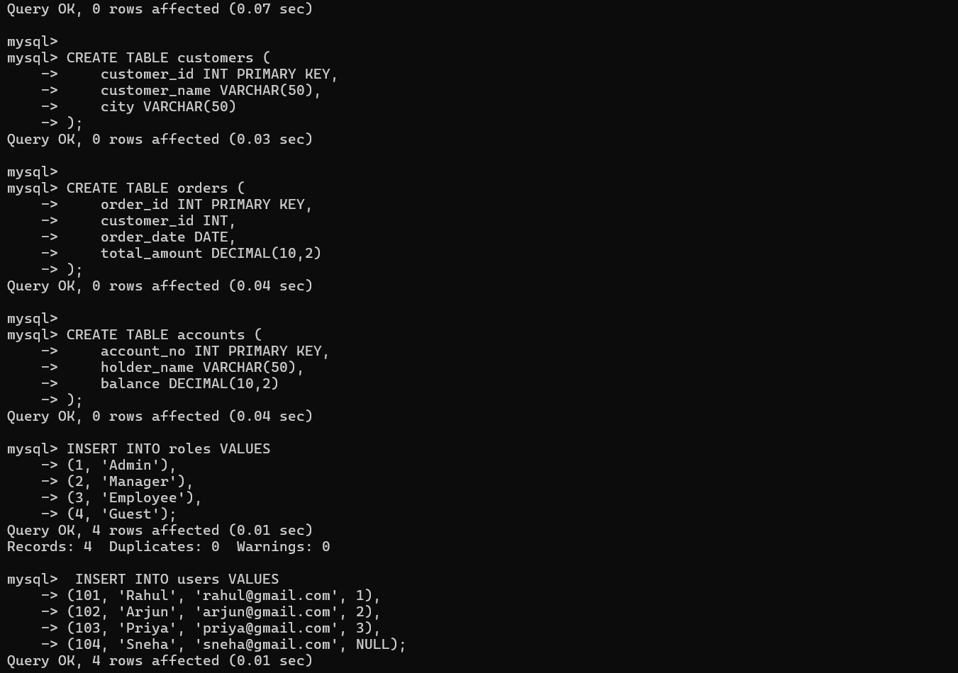
Screenshot 2: Schema definition for `Customers`, `Products`, `Orders`, and `Order_Details` tables.

3. Populating Departments, Employees, and Projects Data
Populates core organizational data including 5 departments, 16 employees, and initial project assignments.
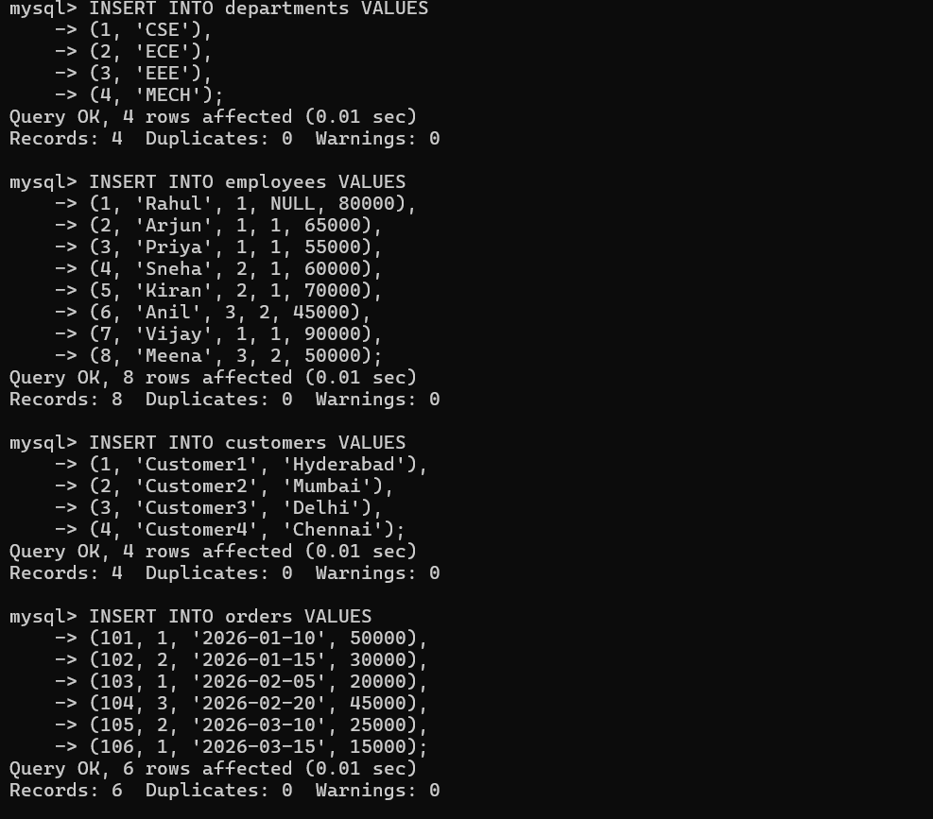
Screenshot 3: Data insertion queries into `Departments`, `Employees`, and `Projects` tables.

4. Populating Customers, Products, Orders, and Order Details
Inserts test datasets across product catalog, registered customer accounts, and order history.
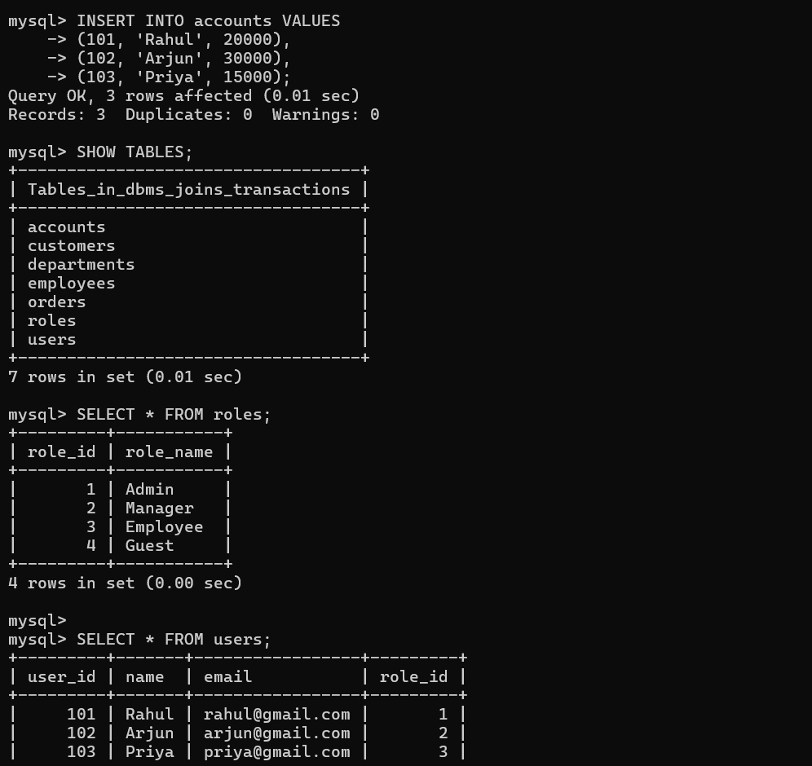
Screenshot 4: Data insertion into `Customers`, `Products`, `Orders`, and initiating `Order_Details` records.

5. Data Operations: Q1 (Insert), Q2 (Subquery Update), Q3 (Delete)
Executes DML operations: adds new employee records, performs conditional percentage salary updates via subqueries, and cleans up underpaid records.
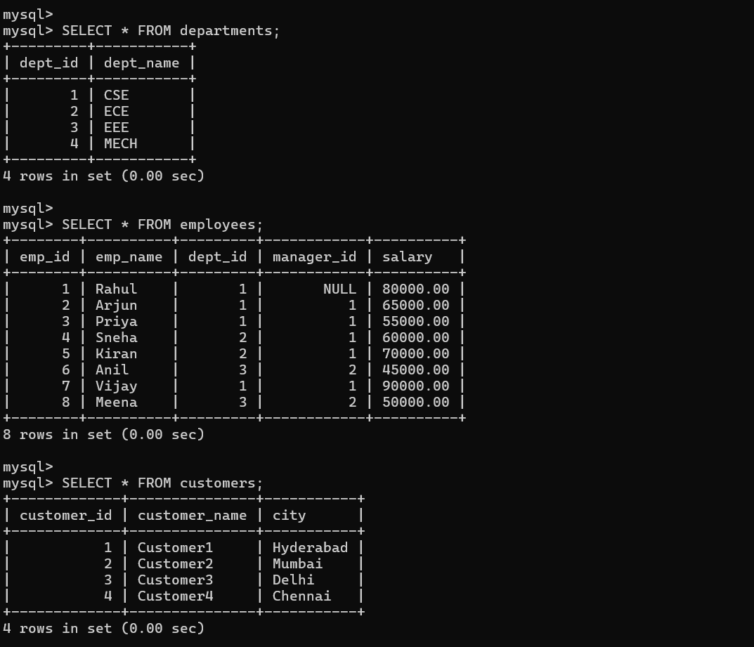
Screenshot 5: Completing `Order_Details` insertions, Q1 (Insert employee 'Varun'), Q2 (10% CSE salary update), and Q3 (Delete low salary).

6. Data Verification (Q4) & Q5 (INNER JOIN)
Verifies modified employee records (15 rows total) and initiates relational join query execution.
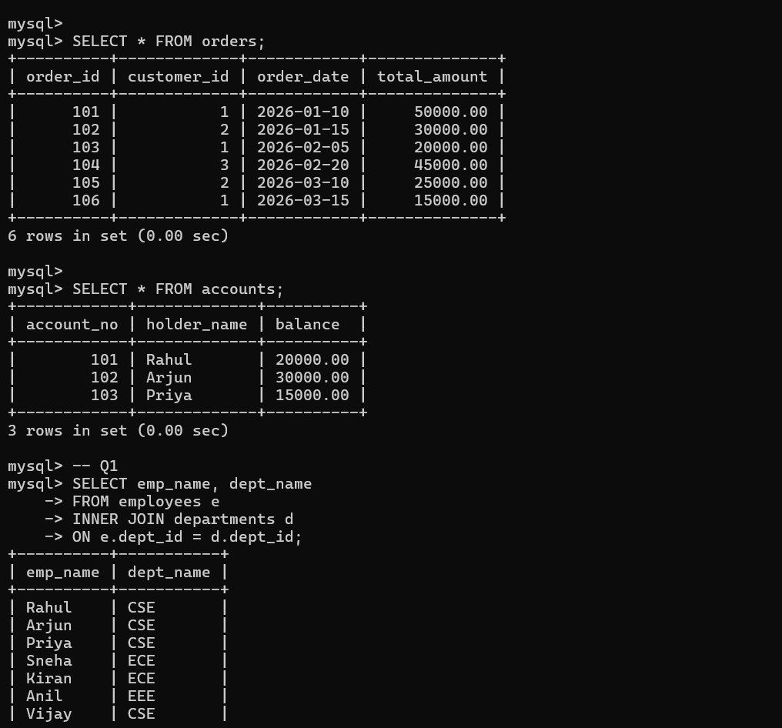
Screenshot 6: Execution of Q4 (Full table scan of updated `Employees`) and initiation of Q5 (INNER JOIN).

7. Outer Join Queries: Q5 Result, Q6 (Unassigned Depts), Q7 Start
Demonstrates relational join techniques including filtering unmatched foreign key relationships.
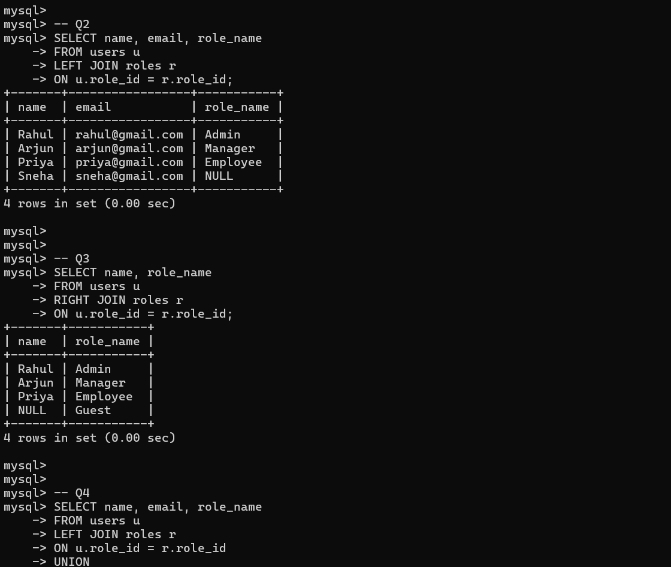
Screenshot 7: Q5 results (14 matched rows), Q6 (LEFT JOIN finding employees without departments), and Q7 execution.

8. Q7 Results (RIGHT JOIN) & Q8 (SELF JOIN for Manager Hierarchy)
Maps manager-employee relationships using self-referencing foreign keys and outer joins.
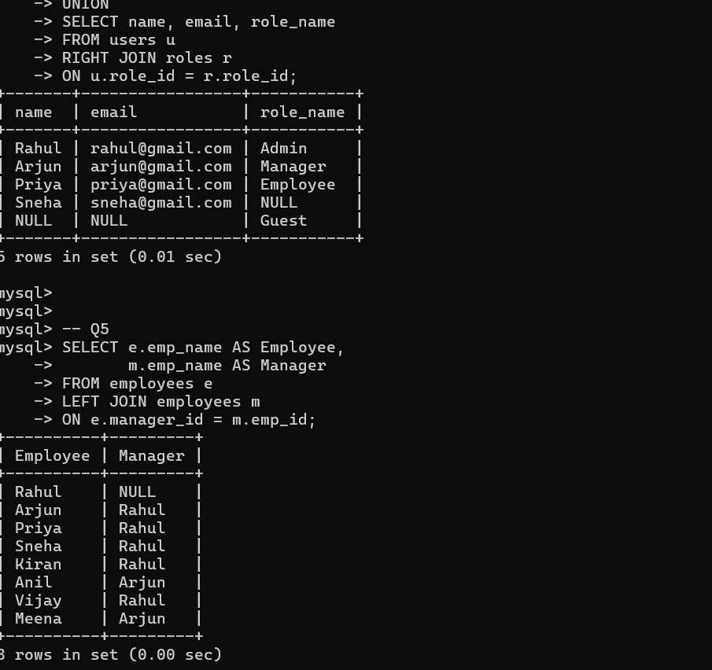
Screenshot 8: Results for Q7 (Department-to-Employee LEFT JOIN) and Q8 (SELF JOIN on Employees).

9. Aggregation & Subquery Filtering: Q9, Q10 (GROUP BY), Q11 (HAVING)
Performs group aggregation functions to compute department salary averages and filters results using `HAVING`.
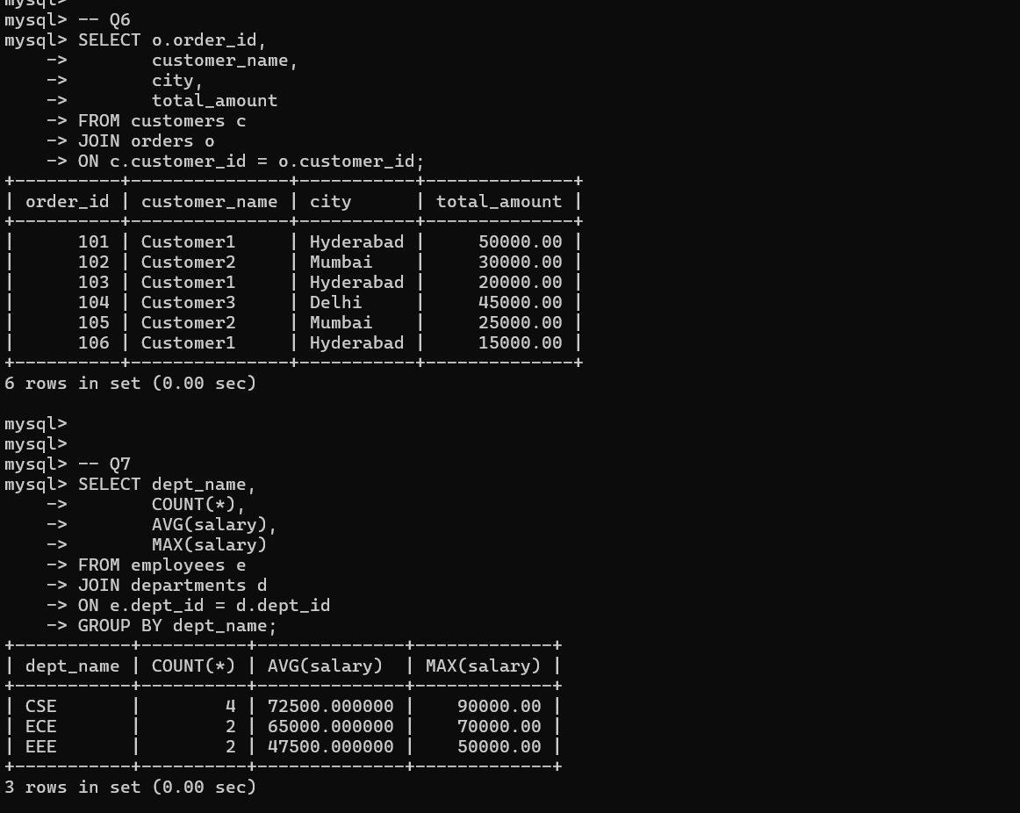
Screenshot 9: Execution of Q9 (`COUNT(*)` total employees), Q10 (`AVG(salary)` grouped by dept), and Q11 (`HAVING` filter > 60,000).

10. Aggregate Extreme Metrics (Q12) & Above Average Subquery (Q13)
Calculates highest/lowest salary thresholds and filters employees earning more than the calculated company average salary.
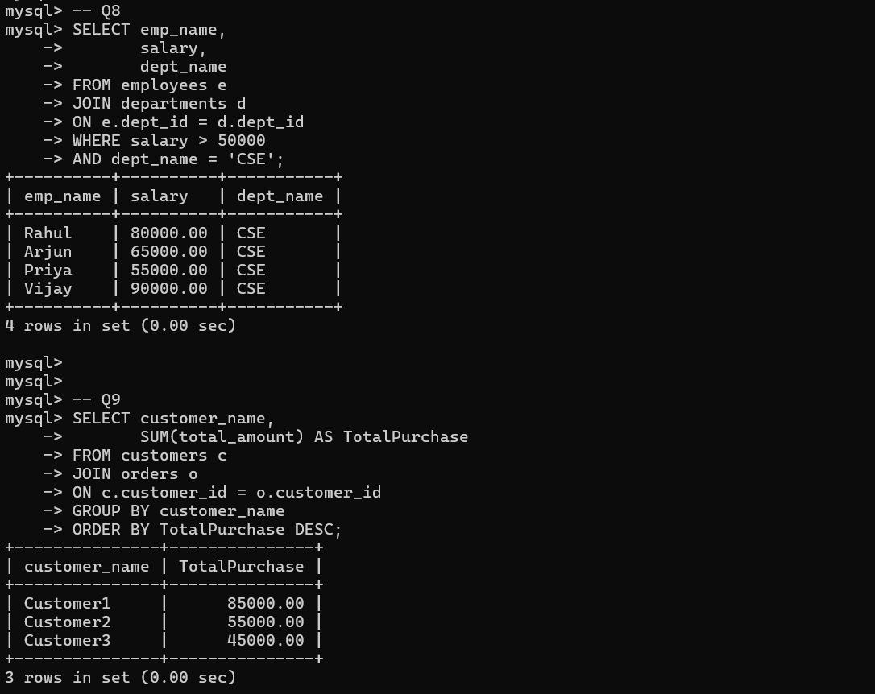
Screenshot 10: Execution of Q12 (`MAX`/`MIN` salary) and Q13 (Subquery filtering employees earning above overall average).

11. Subqueries & Max Salary Filter: Q14 & Q15
Uses nested single-value subqueries to match departmental attributes and retrieve maximum earners.
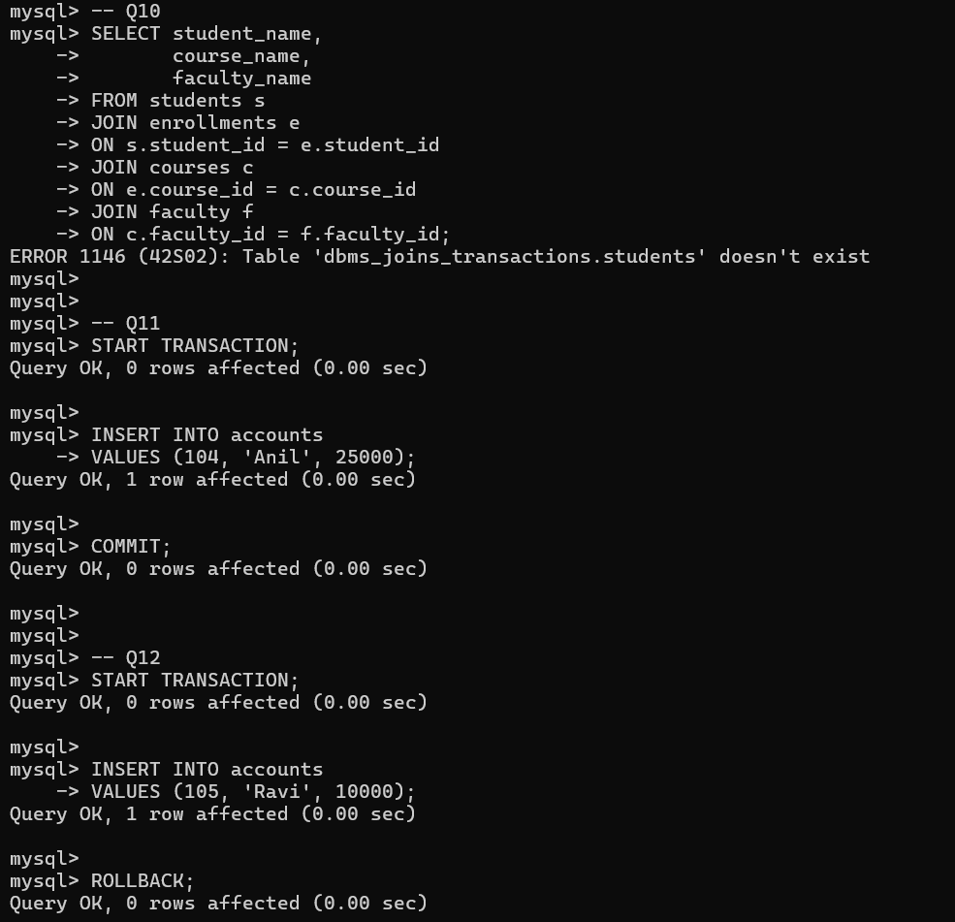
Screenshot 11: Execution of Q14 (Employees in same department as 'Rahul') and Q15 (Employee with maximum salary).

12. Department Size Filtering: Q16 (`HAVING` clause)
Groups employee counts per department and returns departments exceeding size thresholds.
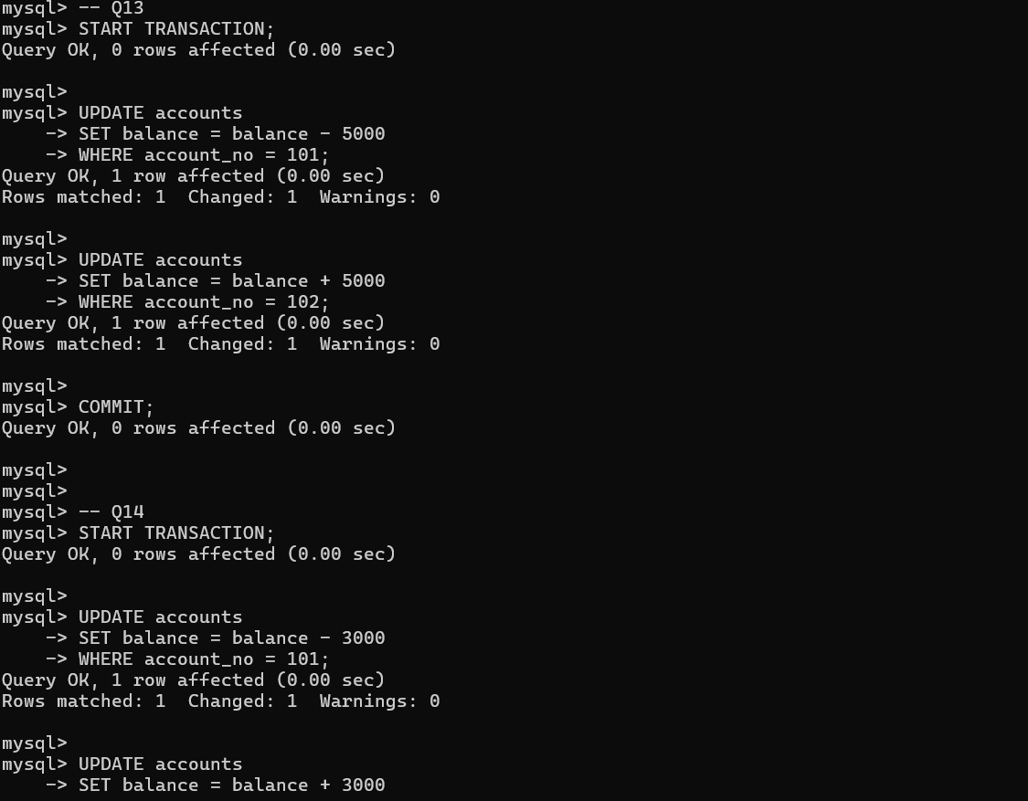
Screenshot 12: Execution of Q16 (Departments with employee count greater than 5).

13. Window Functions & Outer Join Filtering: Q18 & Q19
Demonstrates window functions for intra-partition metric comparisons and outer joins to identify inactive customers.
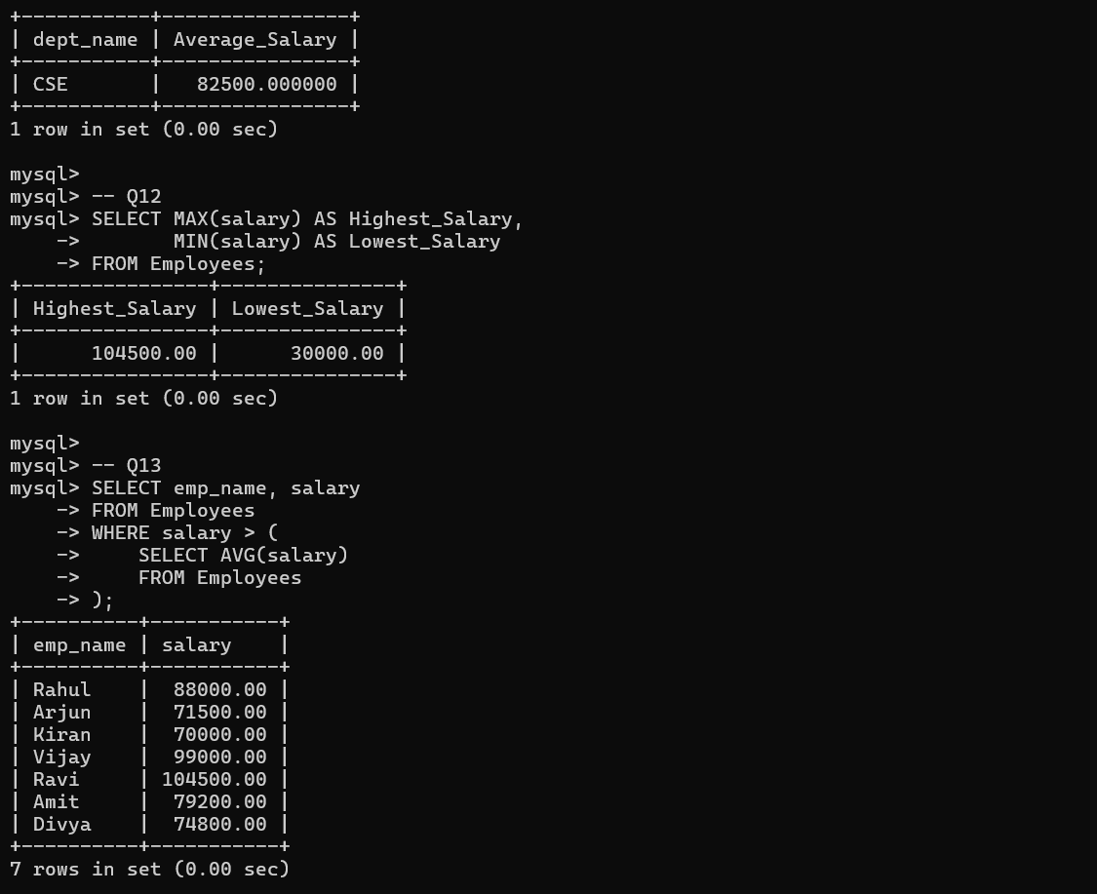
Screenshot 13: Execution of Q18 (Window function `PARTITION BY` for departmental average salary comparison) and Q19 (Customers without orders).

14. Top Sold Products & Max Department Size Subquery: Q20 & Q21
Finds top-performing product entities (`Keyboard` with 13 total sold) and calculates maximum department size using nested aggregations.
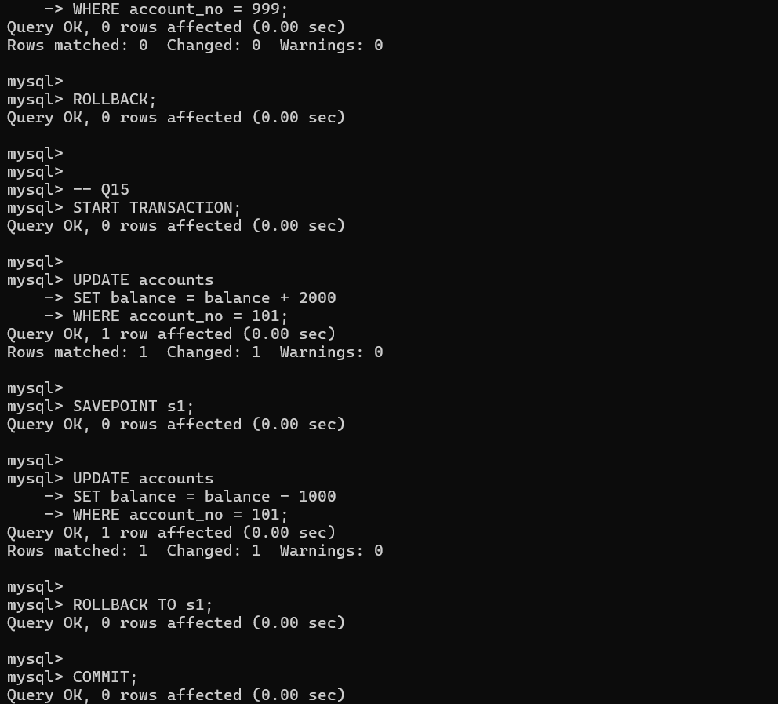
Screenshot 14: Execution of Q20 (Top selling product by quantity) and Q21 (Department with maximum employee count via nested subquery).

15. Analytical Window Functions: Q21, Q22 (Running Sales), Q23 (Customer Spend Ranking)
Computes monthly cumulative revenue using `SUM() OVER()` and ranks customer total purchase volume using the `RANK()` window function.
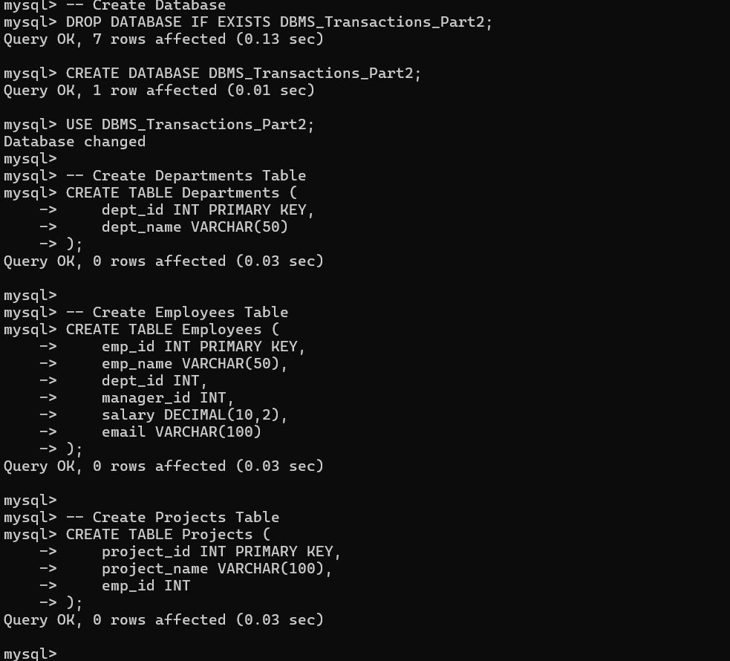
Screenshot 15: Execution of Q21 (Max Dept Count), Q22 (Monthly Sales & Running Sales OVER Window), and Q23 (Customer Spend Ranking via RANK()).

16. Advanced Self Joins & Duplicate Detection: Q24 & Q25
Identifies employees out-earning their direct managers (`Vijay` and `Ravi`) and checks for email uniqueness constraint violations.
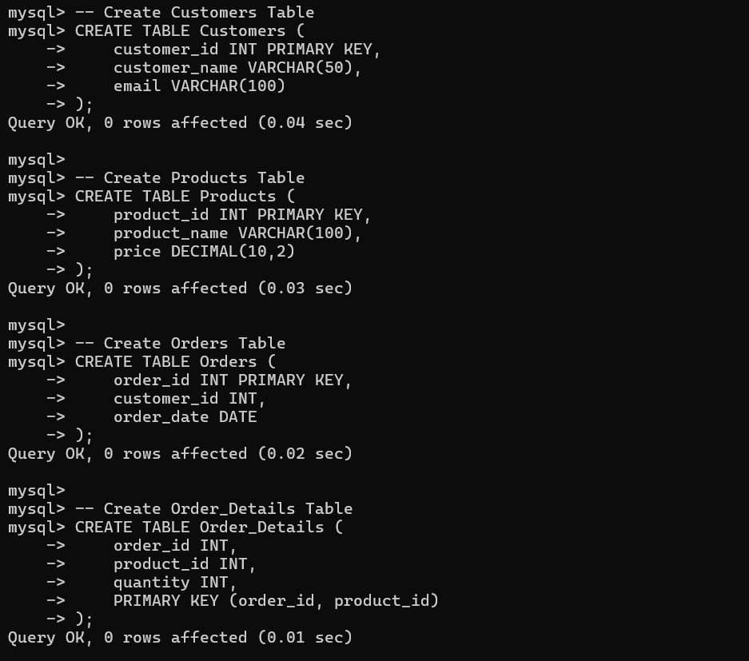
Screenshot 16: Execution of Q24 (SELF JOIN filtering employees earning more than their manager) and Q25 (Duplicate email check via HAVING COUNT(*) > 1).

